Student Name: ____Lim Xin Yi________________________

Group : _____TCCA_______________________

Date : ______30/10/2023______________________

LAB 4: ANALZING NETWORK DATA LOG

Please download the data file, in .csv format, from the NTULearn lab site (not the lecture site). Write the program to do the exercises below.

Exercise 4A: TOp TALKERS and LISTENERS

One of the most commonly used function in analyzing data log is finding out the IP address of the hosts that send out large amount of packet and hosts that receive large number of packets, usually know as TOP TALKERS and LISTENERS. Based on the IP address we can obtained the organization who owns the IP address, using https://whatismyipaddress.com/

List the TOP 5 TALKERS

Rank | IP address | # of packets | Organisation
1 | 193.62.192.8 | 3041 | European Bioinformatics
2 | 155.69.160.32 | 2975 | NTU
3 | 130.14.250.11 | 2604 | National Library of Medicine
4 | 14.139.196.58 | 2452 | Indian Institute of Technology (IIT) Guwahati
5 | 140.112.8.139 | 2056 | Taiwan Academic Network

List the TOP 5 LISTENERS

Rank | IP address | # of packets | Organisation
1 | 103.37.198.100 | 3841 | A*STAR
2 | 137.132.228.15 | 3715 | NUS
3 | 202.21.159.244 | 2446 | Republic Polytechnic
4 | 192.101.107.153 | 2368 | Battelle Memorial Institute Pacific Northwest Division
5 | 103.21.126.2 | 2056 | Powai

Exercise 4B: TRANSPORT PROTOCOL

Using the IP_protocol field value, determine the number of packets for each protocol. For finding the transport layer protocol based on the IP_protocol field value, you can use https://www.iana.org/assignments/protocol-numbers/protocol-numbers.xhtml

 | IP_protocol field value (in decimal number) | Transport layer protocol | # of packets
1 | 6 | Transmission Control (TCP) | 56064
2 | 17 | User Datagram (UDP) | 9462
3 | 50 | Encap Security Payload | 1698
4 | 47 | Generic Routing Encapsulation | 657
5 | 41 | IL Transport Protocol | 104
6 | 1 | Internet Control Message (ICMP) | 74
7 | 58 | ICMP for IPv6 (IPv6-ICMP) | 4
8 | 0 | IPv6 Hop-by-Hop Option | 1
9 | 103 | Protocol Independent Multicast | 1

Exercise 4C: ApplicationS PROTOCOL

Using the Destination IP port number, determine the most frequently used application protocol.
(For finding the service given the port number https://www.adminsub.net/tcp-udp-port-finder/ )

Rank | Destination IP port number | # of packets | Service
1 | 443 | 13423 | HTTPS
2 | 80 | 2647 | HTTP
3 | 52866 | 2068 | Dynamic and/or Private Ports
4 | 45512 | 1356 | Unassigned
5 | 56152 | 1341 | Dynamic and/or Private Ports

Exercise 4D: Traffic

The traffic intensity is an important parameter that a network engineer needs to monitor closely to determine if there is congestion. You would use the IP packet size to calculate the estimated total traffic over the monitored period of 15 seconds. (The sampling rate is 1 in 2048. You can either use 1MB = 2²⁰ bytes or 1MB = 10⁶ bytes. Both ways will be counted as correct.)

Total Traffic (MB) | 64777822 bytes * 2048 / 10⁶ = 132665 MB (6s.f.)

Answers for Part 4(E) and 4(F) on next page
Exercise 4E: ADDITIONAL ANALYSIS
Top 5 communication pairs
src_IP | dst_IP | Count
193.62.192.8 | 137.132.228.15 | 3041
130.14.250.11 | 103.37.198.100 | 2599
14.139.196.58 | 192.101.107.153 | 2368
140.112.8.139 | 103.21.126.2 | 2056
137.132.228.15 | 193.62.192.8 | 1910
From the bolded rows, we can see that the top 1st and 5th communication pairs consist of the same two IP addresses 193.62.192.8 (European Bioinformatics) and 137.132.228.15 (NUS). This suggests that the communication between the two organisations contain request packets that result in responses sent. We also note that European Bioinformatics is the top talker while NUS is the second top listener as stated in part (A).

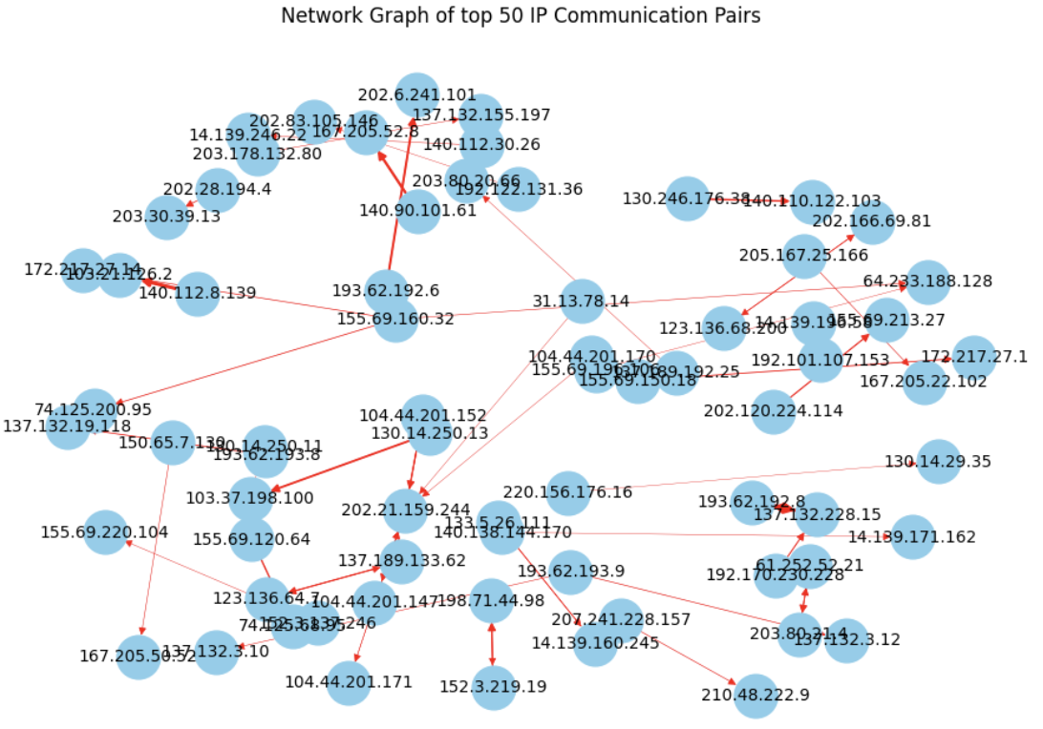
It is also observed that the network of top 50 IP communication pairs has an average node degree of 1.43, meaning each machine on average directly communicates with 1.43 other machines.

Protocol
ethernet_type | Protocol | Count
0x0800 | Internet Protocol version 4 (IPv4) | 67955
0x86dd | Internet Protocol version 6 (IPv6) | 107
0x0806 | Address Resolution Protocol (ARP) | 2
0x0000 |  | 1
Almost 98% (67955 out of 68065) of all FLOW-type packets are IPv4 packets.
There are 107 IPv6 packets, and 2 ARP packets.
Exercise 4F: SOFTWARE CODE

Please submit your code together with your answer sheet to the NTULearn lab site at the end of the laboratory session.

import pandas as pd
import matplotlib.pyplot as plt
import networkx as nx

df = pd.read_csv('SFlow_Data_lab4.csv', header=None)
df = df.iloc[:, :-1]
df.columns = ['type', 'sflow_agent_address', 'inputPort', 'outputPort', 'src_MAC', 'dst_MAC', 'ethernet_type', 'in_vlan', 'out_vlan', 'src_IP', 'dst_IP', 'IP_protocol', 'ip_tos', 'ip_ttl', 'udp_src_port/tcp_src_port/icmp_type', 'udp_dst_port/tcp_dst_port/icmp_code', 'tcp_flags', 'packet_size', 'IP_packet_size', 'sampling_rate']
df = df[df['type'] != 'CNTR']

def top_n(column_name, n):
counts = df.groupby(column_name).size().reset_index(name='count')
descending_counts = counts.sort_values(by='count', ascending=False)
return descending_counts.head(n)

# part a
# top_5_talkers
print("\nTop 5 Talkers: ")
print(top_n('src_IP', 5))
# top_5_listeners
print("\nTop 5 Listeners: ")
print(top_n('dst_IP', 5))

# part b
# all IP_protocols
print(top_n('IP_protocol', 20))

# part c
# top 5 destination ports
print("\nTop 5 Destination Ports: ")
print(top_n('udp_dst_port/tcp_dst_port/icmp_code', 5))

# part d
print("\n Total traffic in megabytes: ")
print(df['IP_packet_size'].sum() * 2048 / 1000000)

# part e
print("\n(E)")
# top 5 communication pairs
print("\n Top 5 communication pairs by IP address: ")
top_5_comm_pairs = top_n(['src_IP', 'dst_IP'], 5)
print(top_5_comm_pairs)

# all ethernet_types
print(top_n('ethernet_type', 10))

# Network graph for top 50 communication pairs

top_50_comm_pairs = top_n(['src_IP', 'dst_IP'], 50)

# Initialize a multi-directed graph
G = nx.MultiDiGraph()

# Add edges to the graph with weights based on the frequency of communication
for index, (src, dst, count) in top_50_comm_pairs.iterrows():
G.add_edge(src, dst, weight=count)

# Draw the network graph
plt.figure(figsize=(12, 8))
pos = nx.spring_layout(G, k=1.5, iterations=16)
nx.draw_networkx_nodes(G, pos, node_size=700, node_color='skyblue')
nx.draw_networkx_edges(G, pos, width=[d['weight']/1000 for (u, v, d) in G.edges(data=True)], edge_color='red', node_size=700)
nx.draw_networkx_labels(G, pos, font_size=10)

plt.title('Network Graph of top 50 IP Communication Pairs')
plt.axis('off')
plt.show()

